**BRM LAB-2**

**Aim:** Unit testing using JUnit tool.

JUnit in eclipse IDE-

Let's write the logic to find the maximum number for an array.

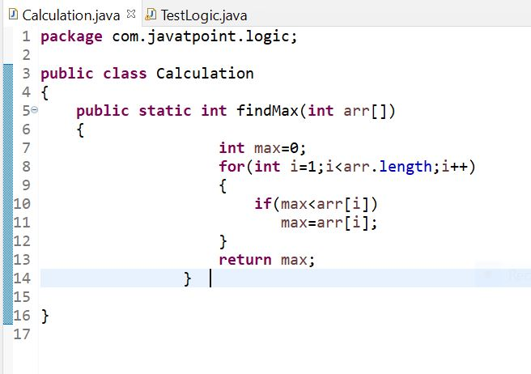

The test case-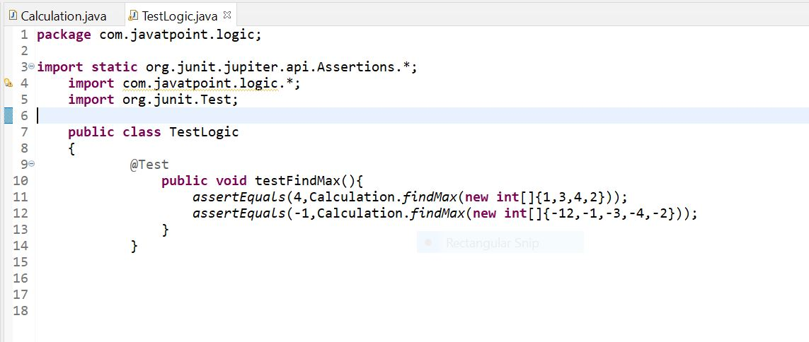

Let's see the output displayed in eclipse IDE.

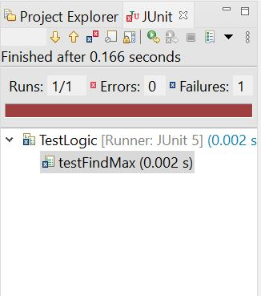

**Output:** Assertion Error

When we pass the negative values, it throws Assertion Error because second time findMax() method returns 0 instead of -1. It means our program logic is incorrect.

Correct program logic

Program logic to find the maximum number for the given array is not correct because it doesn't return -1 in case of negative values. The correct program logic is given below-

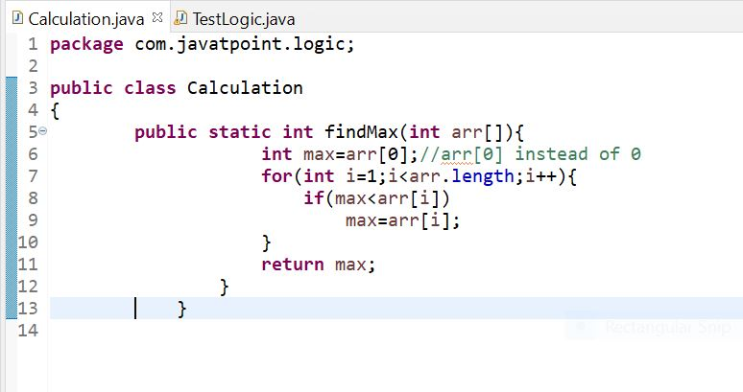

Run the JUnit program again, you will see the following output-

